REAL OZ BLITZ
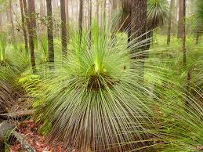
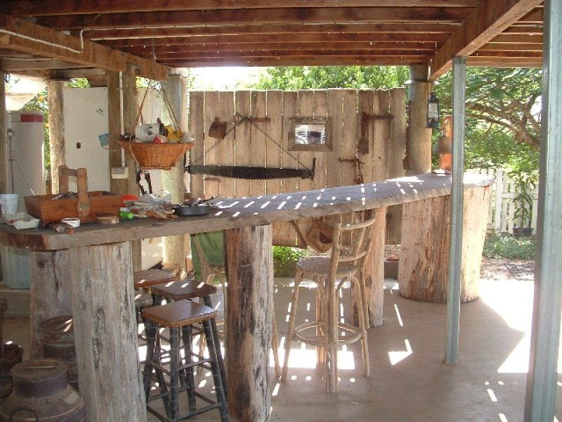
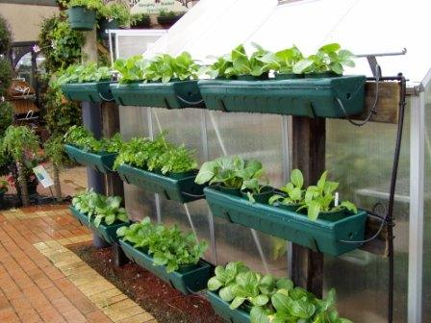
REAL

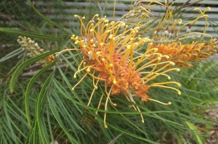
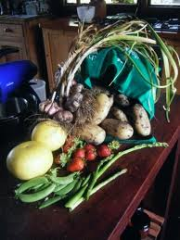

REAL ALLIANCE LAND & COASTCARE
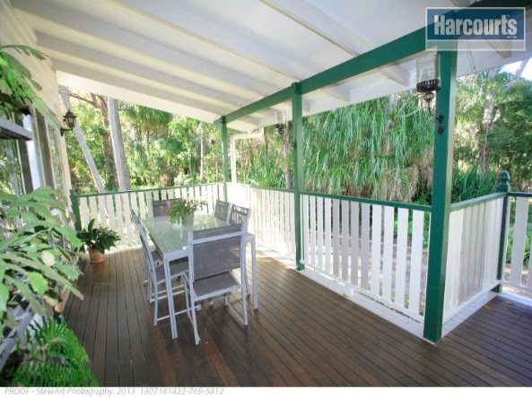
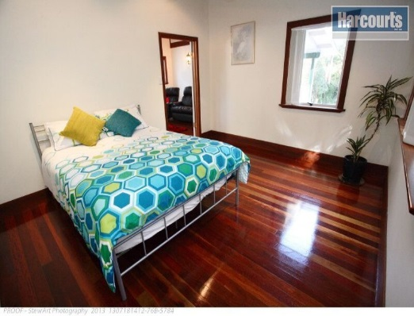

Back & Front Yard Makeover and Home Improvement’s for Real!

Eco - Sustainable Make-Overs & Design for your Home, Garden and Townscape

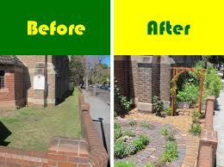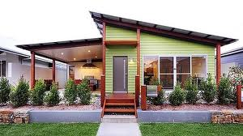

We can improve your home with our eco---sustainable home make-over, or to give it street appeal with a modern eco-sustainable touch that meets your budget!
Landscape ideas, Landscape design & Landscape installations, Retaining walls,
Fencing & Gates of all types e.g. timber, metal. Pergolas, Decking, Patios & more
Front Home Updates; Render, Windows, Doors, Lights, Decking, Painting,
Rockeries, Ferneries, Paving, Concreting, Driveways, Paths etc.
Water features, Ponds, Pool surrounds and more…
Trade services: Engineering, Architecture/Design, Plumbing, Electrical, Bricklaying, Painting, Rendering, Chippy’s & more…

- Grey water reuse & diversion systems with passive irrigation installation - Solar Energy Systems - Sustainable Home Assessment
“Our Service will value add, enhance and improve the aesthetics of your Home”
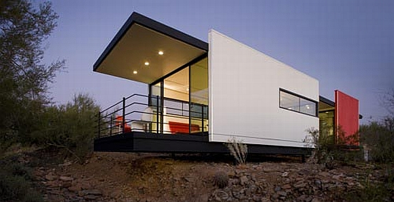
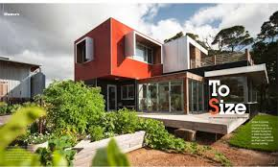
IMPROVE YOUR LOT
We offer the highest quality of sustainable & environmental home design and workmanship, with home energy, water and recycling management systems.
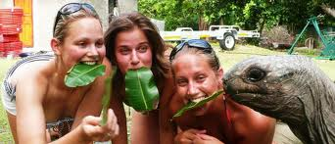
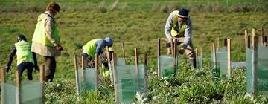
ECO HOUSE MAKEOVER ~ a Project of REAL Alliance and also a new TV and Satellite TV Series to be viewed in 2014 throughout Australia, The USA, Canada and Europe.
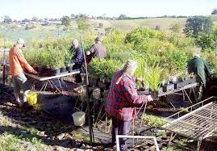
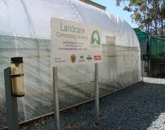
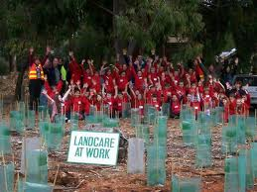

REAL ALLIANCE LAND and COASTCARE SEEKING THE CONSERVATION GENERATION
Real Alliance, a registered Landcare Group are seeking those of the conservation generation to come on board. Real Alliance gets real to regenerate the environment and benefit animals lives in Australia and globally. Enquire about the various projects.
Hervey Bay is set to be the first Australian town to receive a Real Alliance Makeover INCLUDING ITS’ NATURAL SPACES so providing green opportunities to all locals and visitors.

Help out in your own backyard - OZ – VISIT the Real Landcare page on the Landcare website and there is a donations page where you nominate which Landcare Group:
http://nld.landcareaustralia.com.au/ViewSearchGroupDetailsNL.aspx?accountid={64658F08-3460-E211-89A2002264A2D0EE (cut and paste this web address to the search box of your web browser.)

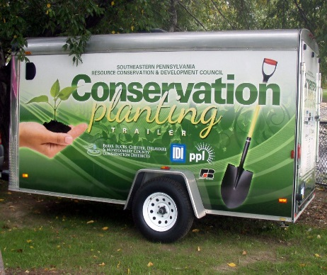
Web: www.arealventure.com
Real Land and
Coast Care
Alliance

E-mail: arealventure@gmail.com

0488 642 155 Premises in Maryborough

A HOME THAT IS A REAL ALLY
A REAL OZ ECO SMART HOME
CAN INCLUDE ANY OF THE FOLLOWING
- A Garden Makeover – clean and tidy up, weeding, trimming trees and shrub, new mulch and/or pine bark, new native and other plants throughout the garden.

- An edible vegetable and fruit and nut tree EcOrchard and a herb garden.

- Landscape design & Landscape installations, Retaining walls, Fencing & Gates of all types e.g. timber, metal. Pergolas, Decking, Patios.

- Rockeries, Ferneries, Paving, Concreting, Driveways, Paths etc. Water Features, Ponds, Pool Surrounds, Solar Pool Heating & Fencing, Water Tanks, Guttering, Eco Insulation, Roofing, Solar Tubes, Whirlybirds, Skylights and more.

- Home Updates; Power, Energy Saving Light Bulbs and Devices, Water Saving Devices, Compost Toilets, Solar Ovens, Energy Saving Appliances.

- Exterior Render, Windows, Doors, Lights, Decking, Painting, home flood and fire protection – (door and window barriers and roof sprinklers).
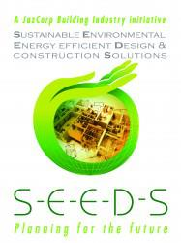
- Grey water reuse & diversion systems with passive irrigation installation. This requires a REAL change of cleaning and washing products to Eco Friendly.
- Solar Energy Systems, Wind and Hydro Power also.
- Water Catchment installations, tanks, ponds, dams.
- Sustainable Home Assessment at the completion.

REAL OZ HOME - OTHER BENEFITS

- The home is listed on our website with photographs and property details. You or an agent are able to sell the home. A SIMPLE CONTRACT IS SIGNED.

- You can pay for the Eco Home Makeover all prior to the sale, or start the project to show commitment and then when the sale goes through and you receive the funds from the sale transaction, the makeover can be completed in the following 4 – 8 weeks and then handed over to the new owner.
That way the new owners are able to choose where devices are to be placed, colours to be painted, design of garden and home additions.

- REAL ALLIANCE project manages the Eco Home Makeover and contracts local companies / sole traders to carry out each aspect. All have relevant licenses and insurances. (The project is also reliant on their availability, yet due to the higher quality and creative level of a REAL OZ HOME, they mostly prefer these Ventures to average Jobs that lack imagination and that ensures their loyalty.)

- We can film and photograph the transformation so you and the new owner have that record for future enjoyment. We can feature it in our Community TV Show too.
- We place a sign on the front fence, garden area and on the nearest main road to indicate its significance and notes the property details and photographs,

LIVE IN A REAL OZ HOME Where life is idyllic and sustainable living is a real partaking. You can even sell the home on our website or keep it as a Base, buy a Mobile setup and take off around Australia.

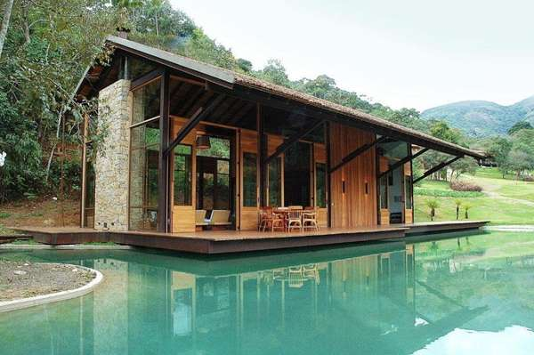
The aim of the venture is to achieve 100% self-sufficient NATURE conservation/living on land with the people of Australia and international Visitors being earnest and real caretakers.
We are reducing dependence on government departments to rescue communities from natural and economic downturns.

IMPROVE YOUR LOT
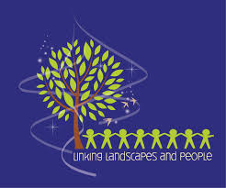

A REAL OZ HOME
A BETTER ENVIRONMENT~A BETTER LIFESTYLE
This home is an Eco Home Makeover Recipient
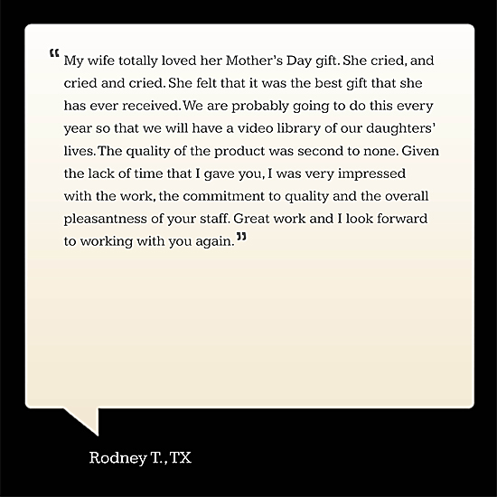
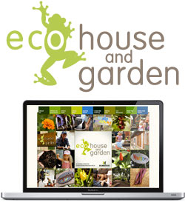

GIVE A GIFT VOUCHER OF A SURPRISE MAKEOVER OR MAKE IT A REAL SURPRISE – GO AWAY FOR THE WEEKEND/WEEK & WE’LL GO FOR IT.
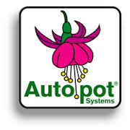

Waterwise Gardening With Autopot Systems
Nearby trees and weeds can rob away most of the water that is being applied in the garden. There is not much you can do except to have your plants grown in containers. However, keeping up with its water requirement is a huge problem particularly during dry summer. Not so if you have the Autopot Systems installed.

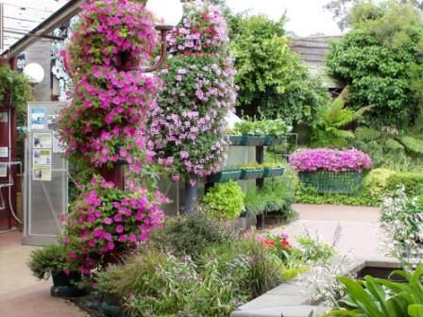 | 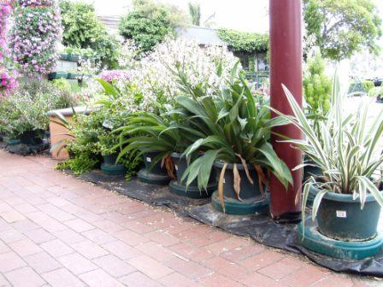  Sunday, 18 November 2007  Plants have certainly flourished with the onset of warmer weather in Spring - a good contrast as compared to the same spot during winter as shown in pictures below.
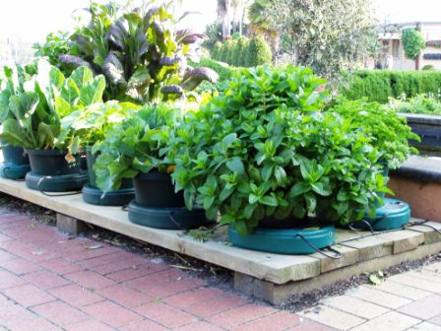  A mixture of vegetables (Mint, caulifowers, Kale, Squash) grown in Autopot Single 12inch Hydrotray units. | 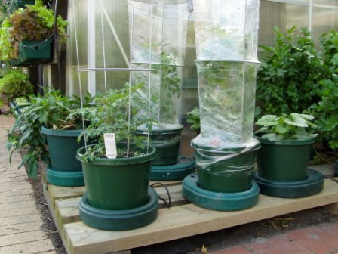  Pic. above - Tomatoes in Autopot Single 12inch Hydrotray.
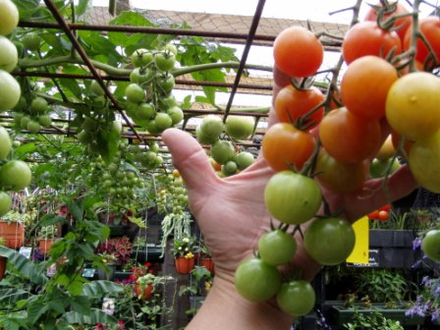  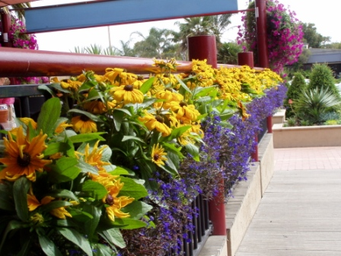  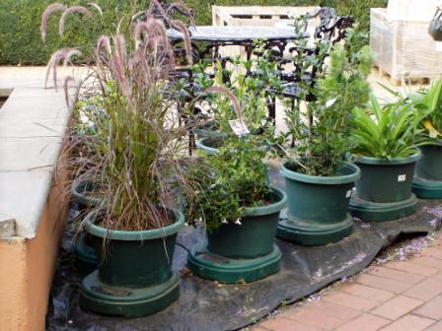 | 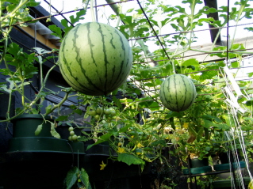  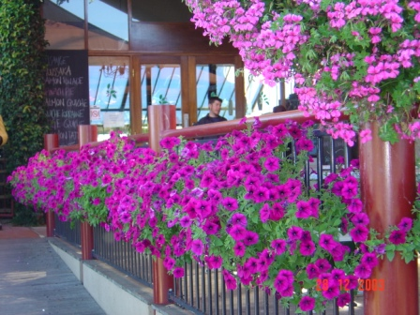  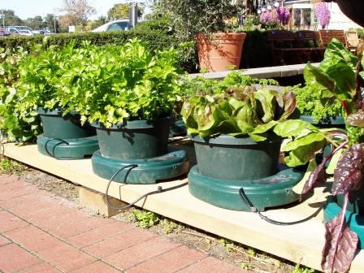  Pic. above - Autopot 12" single tray modules sitting on wooden platform.  Pic. left - Similar set up to above except that instead of timber, the flooring is covered with a layer of weed mat.
 | 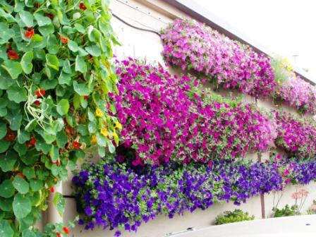
With our services - groups of potted plants grown in Autopot 12" Hydrotray units, serve the idea to overcome the problems of water and nutrient poaching by nearby trees. Ease of watering and great ability to keep nutrients up to the plants.

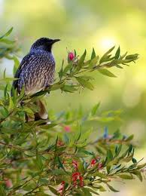
With REAL HOMES assist we can assist you to create a truly GREEN HOME with features like sustainable edible gardens with flourishing purpose built vegetable gardens with fruit trees and herb gardens too. The gardens are grown all year so that people will receive adequate nutrition and therefore won’t have to rely on Supermarkets = cost cutting benefits.
They can feature solar hot water, power, water saving devices even solar ovens, the latest technologies and power saving appliances and more to suit the specific property.
Any of the renovations on your property will be done so with Environ- mentally Friendly Products such as Natural / Eco Paints and Varnishes, Recycled Timbers and there are many renewable products on the market such as Straw Panel, Bamboo Flooring and Paneling.

The homes will therefore be minimal toxicity dwellings for the ultimate health of the occupants. We have researched adequately and are now ready to commence this project and would most highly appreciate your financial and other participation in this Landmark Venture. If you have members of the younger generation they are welcome to be included.
The various new buildings and extensions to existing buildings that form REAL HOMES will have a low environmental footprint and are of natural materials sourced mainly from the local area and the landscaping planned will be primarily natives.
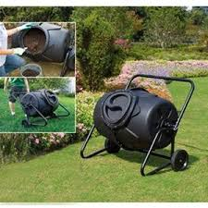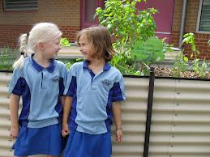

REAL ALLIANCE - PROPERTY MAINTENANCE, PROJECT CONTINUATION
After the home and garden are renovated and/or transformed to be an Eco Home we are able to carry out maintenance in whatever way. This is a real niche Market and we are pleased to offer you this service.
Approximately 25 – 30% are rental properties 15% Commercial Properties and the remainder Private. A certain percentage are acreage properties.
REAL OZ BLITZ – ECO HOME MAKEOVER AND OTHER PROJECTS - A BUSH BASE / REAL RESERVES the Project is a division of REAL Alliance.
REAL Alliance newly formed these Ventures, which is an Integral part of the Global 2020 Vision, The UN H.E.L.P. Vision. All members and directors of REAL Alliance are members of The United Nations, as is Australia a member Country.
A website presence has been created and has also been setup to attract interested parties and volunteers of the various projects. All inhabitants of the SEHLS Properties are duly offered a place in those Projects especially The UN Billion Tree Project, an aspect of The UNEP, further information is available on www.arealventure.com
Real Alliance can oversee properties to ensure they are maintained to the maximum standard and do have all necessary property maintenance equipment. With the enterprise part of the vision, we train in Green Jobs and will be making available much appreciated work to the local community and jobs and volunteer positions to anyone the Project provides housing too, it is an all round symbiotically beneficial Venture.
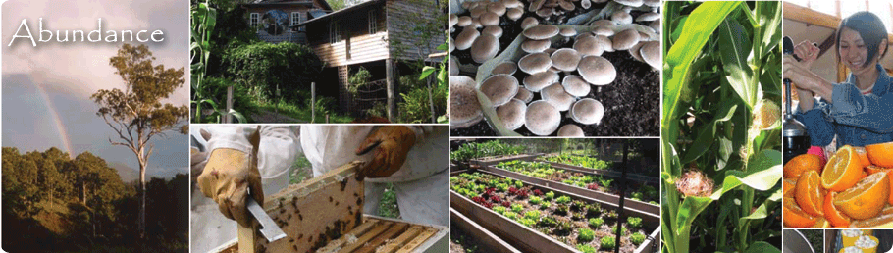
IMAGINE MINIMAL BILLS AND LIVING IN A LOW MAINTENANCE, ULTIMATE HEALTH HOME
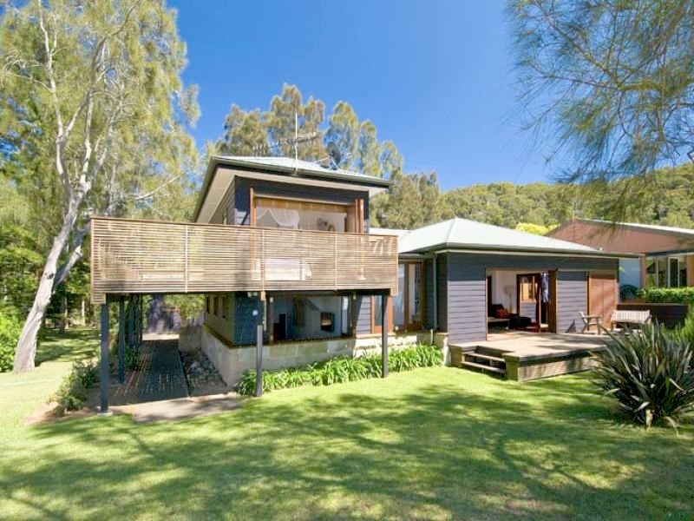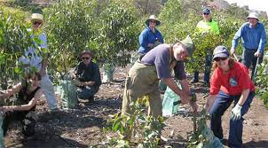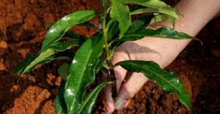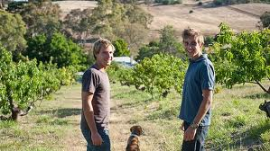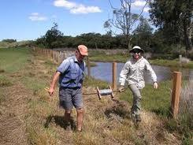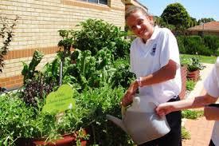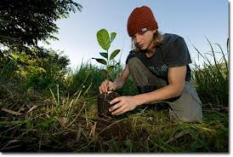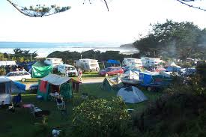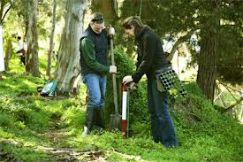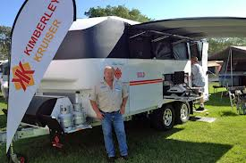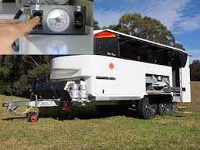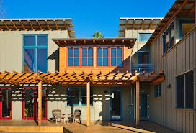
HAVE A Shindig to raise the Green Backs for your New Green Home.
Join our fundraising nights to raise the funds so we can Real Oz Blitz your Home. Do odd jobs around town, go veg picking for a few months to fund it.

REAL ALLIANCE ALSO PROMOTES GLOBE TROTTING – TRAVEL AROUND AUSTRALIA AND VARIOUS MODELS OF TRANSPORT AND ACCOMODATION SUCH AS KIMBERLEY KAMPERS AND JIMBOOMBA CAMPERS AND AUSTRALIAN OUTBACK CAMPERS.
With Transport you can transform your 4WD into an Electric Vehicle. Enquire with us with all these new ways and also look up on the internet all the products from the ABC Show THE NEW INVENTORS

WE PROMOTE NATURAL HOMES – ECO HOMES AND CONNECT WITH A GREEN ARCHITECT NEAR YOU, RAMMED EARTH, EARTH BLOCK, STRAW BALE, STRAW PANEL, BAMBOO, RENEWABLE TIMBERS, SOLAR POWER, APPLIANCES SPECIFIC FOR SOLAR .

On your Land or Farm incorporate Landcare Activities, create Nature Reserves, Wind Breaks and Repair Erosion Areas & Sustainable Farming Practices.
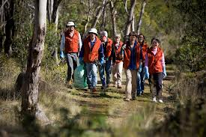
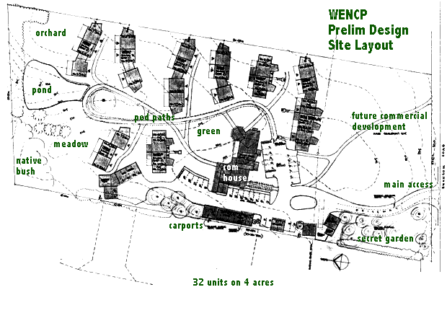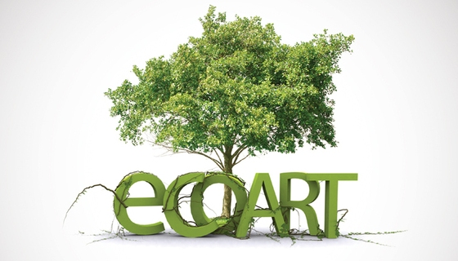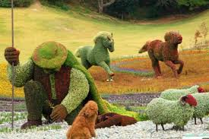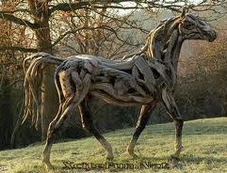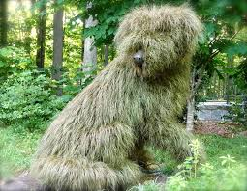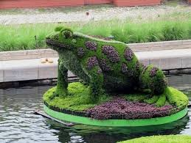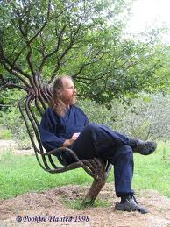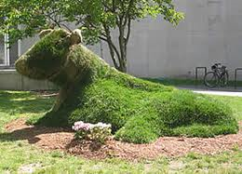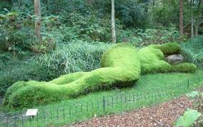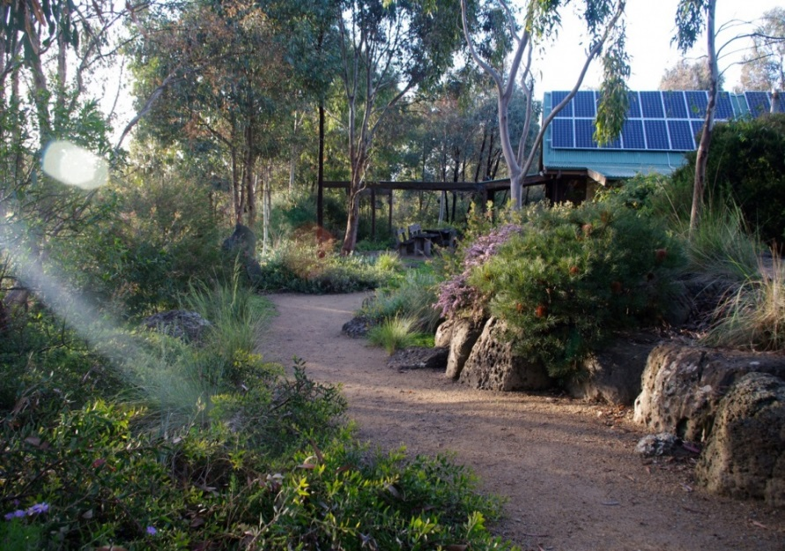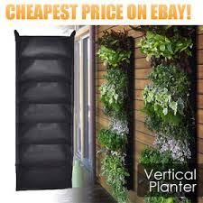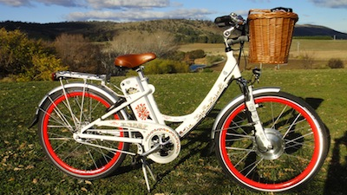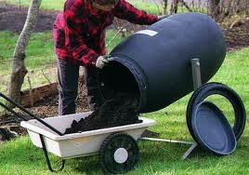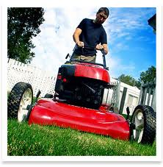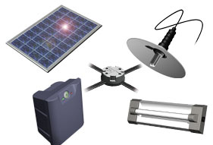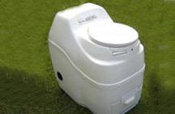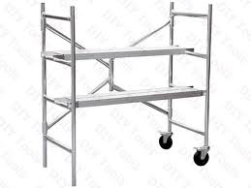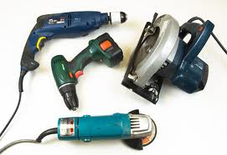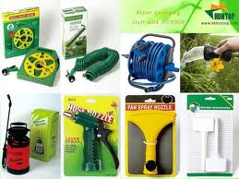
LVING ART SCULPTURES AND OTHER FEATURES
ALL THROUGH EUROPE AND NORTH AMERICA NOW IN AUSTRALIA
TO YOUR DESIGN OR OURS AND EASY MAINTENANCE
Topiary, Earth & Turf, Weaved Trees even mown grass patterns.

OUR ONLINE STORE
Also features Cool additions to your Life like Electric Bicycles, Composting, Tools and Gardening Equipment and Tools, Worm Farms and all manner of Building Materials. (From various suppliers)

Also Solar Lighting and Solar, Wind and Hydro Power, Composting Toilets and Solar Oven – check out the Rainbow Power Company.
AS PART OF THE REAL OZ BLITZ MAKEOVER WE CAN ORGANISE YOUR GARAGE TOOLS & STORAGE
EVEN
HOME CUPBOARDS AND BUILD NEW ULTIMATE ORGANISED SHELVING AND RACKS FOR YOUR CLOTHING AND SHOES.
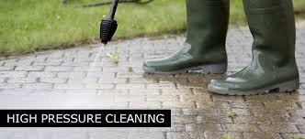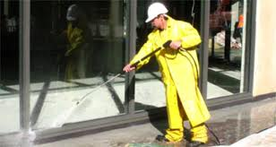
We can arrange a whole range of experts like High Pressure Cleaners, Tree Trimmers, Mulch and Chippers, Pond and Pool Suppliers and they all put them in for you.

Sheds and Natural Built Shed Buildings

We also have contacts to establish a commercial food production on your Land or Farm.
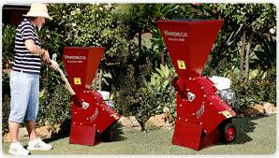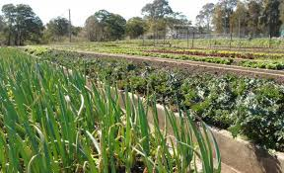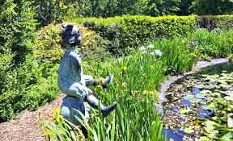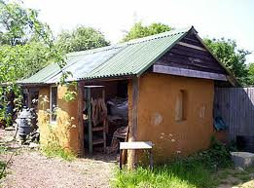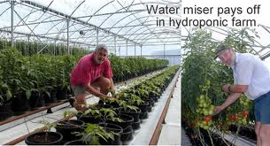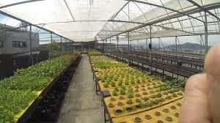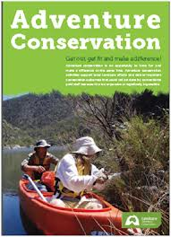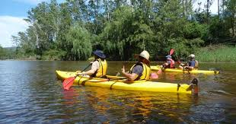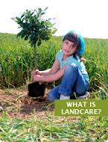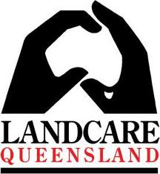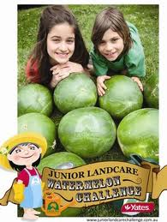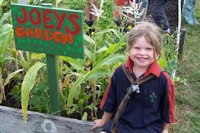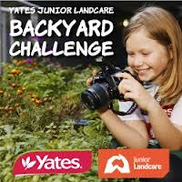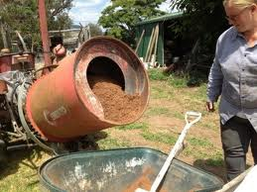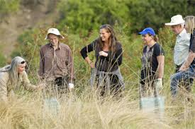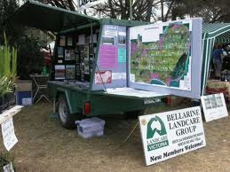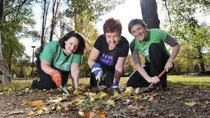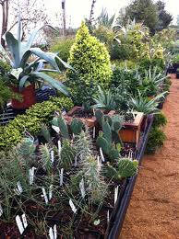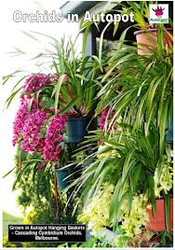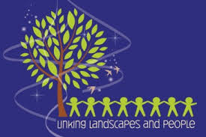

Our Real Alliance Land and Coast Care Group is far from boring, we aim to provide a range of experiences and even promote Green Nomads, Eco – Nomads, Eco and Wildlife Tourism Travel and Global Change Travel

